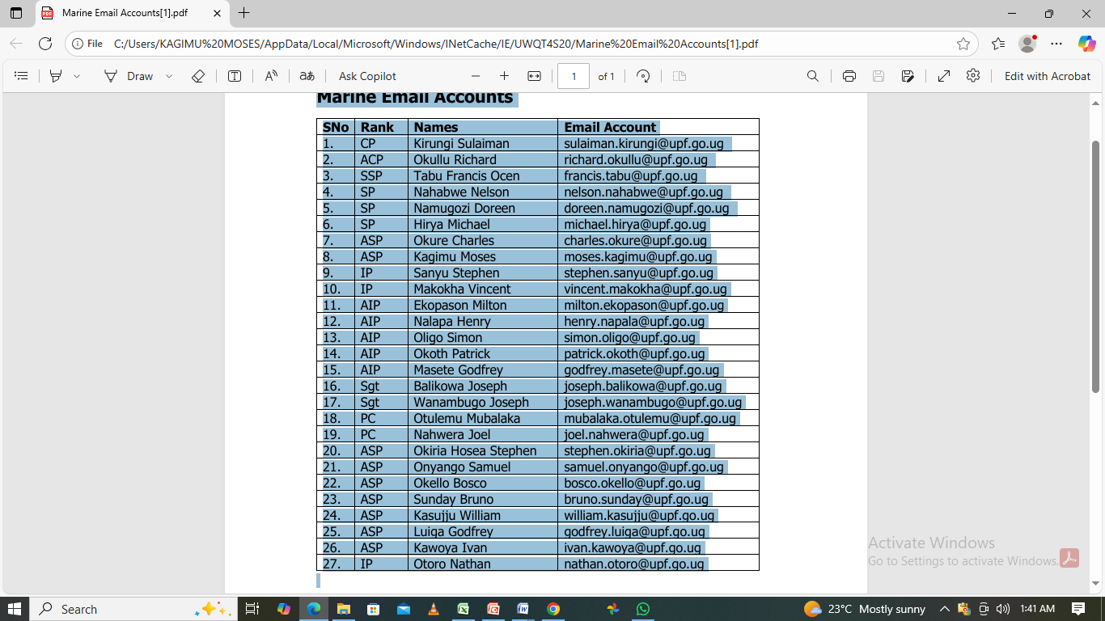
Default Password: Police@123
New Password guidelines - Must be 10 characters - Must have two capital letters - Must have a special character - Must have a figure and a punctuation mark
url - mail.upf.go.ug (on any network) - 10.20.17.238 strictly on Intranet (our local network)

